The Case against Type Substitution

I have promised to provide you with a formal dissertation as to why the use of type substitution as a foundation design choice in the creation of the XML Schema version of FpML is a substantial liability that significantly limits its ability to be implemented using XML centric applications and imposes inordinate burdens on developers. It obviates any of the leveraged advantages of declarative programming methodologies based on XML, yet provides virtually no efficiencies or benefits.

When building a metadata model (a schema) in XML Schema, a design practice that results in the schema having the greatest degree of functional clarity, versatility and usability is to construct it so that it is possible to generate an instance of the object being modeled directly from the schema. The methodology for doing this is very straightforward and universally observed: declare the schema objects as global elements or attributes. Within the last three years every industry initiative (with the exception of FpML) to define standardized metadata objects using XML Schema uses the well understood conventions of declaring elements and attributes and using simple or complex types to define the declared objects (within the financial and insurance sector SWIFT, FIXML and ACORD are examples of such initiatives).The value and benefits of following this simple design dictum are substantial.

- It allows the schema to be used as a transportable instruction set that can be used by any XML Schema enabled host application to provide a service using, or on behalf of the instance object defined by the schema.

- It facilitates declarative programming whereby a good deal of programmatic effort that previously required writing procedural code is now a much simpler matter of configuring parameters defined by the schema.

- The schema can be bound to or encapsulated in objects that can be compiled.

- It facilitates a clean, direct design of objects that can be clearly understood and accessed by any XML technology.

- Every XML protocol and every XML-enabled application, by every vendor under the sun supports the access and manipulation of XML structure based on elements and attributes while there is virtually no support for accessing and manipulating types.

FpML steps outside of the standardized convention by eschewing global elements and attributes and instead defines all of its objects as types. The handful of declared abstract elements has no functional value except to serve as containers for type definitions that define what the element is. There is no rationale for this design decision outside of the following statement in the FpML specification:

“The FpML message framework is based on type substitution (option 3 - By Element Type) as it gives the greatest control over validation whilst allowing easy extension of the message elements.:

Extensibility of the FpML schemas (which is far from being the most important issue to most FpML implementers) could have been obtained using other XML Schema mechanisms such as substitution groups or the “any” facility. Essentially, by designing FpML around type-substitution, the tail is wagging the dog. And what value does the tail provide for having traded away all of the rich capabilities and efficiencies that XML declarative programmability provides? For all intents and purposes FpML is congenitally defective and unusable because it cannot take advantage of any of the development efficiencies afforded by XML technologies and XML schema enabled applications. Yes, a programmer can hand code around type substitution and build custom applications procedurally, but they must do this (at great cost and effort) because they are deprived of the benefit of working with leveraged tools and applications. FpML can only be deployed in one-off, custom applications.

I would like to use the DSWG specification as an object lesson substantiating the contention that a specification built on type substitution is practically worthless. Below is an image showing what the DSWG schema should look like if it was created using elements and attributes. Such a schema could then be used in any number of XML-enabled applications for querying, mapping, aggregating, processing, exchanging and analysis purposes.
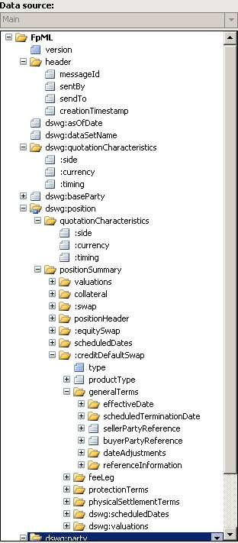

Below is the actual structure of the DSWG schema. There are only global type definitions, no global elements or attributes (except for the irrelevant creditDefaultSwapOption). Consequently the schema cannot be used for any functional purpose (outside of validating an instance document) within any XML-enabled host application.

- Schema Document Properties
- Global Declarations
  - Element: creditDefaultSwapOption
- Global Definitions
  - Complex Type: BasketConstituent
  - Complex Type: Commission
  - Complex Type: CreditDefaultSwap
  - Complex Type: CreditDefaultSwapOption
  - Complex Type: DividendPayout
  - Complex Type: InterestLeg
  - Complex Type: InterestRateStream
  - Complex Type: PendingPayment
  - Complex Type: Position
  - Complex Type: PositionBreakdown
  - Complex Type: PositionHeader
  - Complex Type: PositionReferenceId
  - Complex Type: PositionReport
  - Complex Type: PositionSummary
  - Complex Type: Price
  - Complex Type: ScheduledDate
  - Complex Type: ScheduledDates
  - Complex Type: ScheduledDateType
  - Complex Type: SettlementRateOption
  - Complex Type: SingleUnderlyer
  - Complex Type: TotalReturnLeg
  - Complex Type: Trade
  - Complex Type: TradeAndEvents
  - Complex Type: Valuations
  - Model Group: UnderlyingAssetAdditionalDetails.model

Let’s examine the ramifications of this. If a prime broker is generating DSWG reports for one buy side client, they can easily generate DSWG reports for any of them. However, the greater majority of buy-side firms do not have the technical resources to build a custom system that can consume and process a DSWG report. If however, DSWG reports were generated using elements (instead of type substitution) there are any number of off the shelf tools that would allow any buy side firm to accept and process DSWG reports. That would be a significant value to both the sell side and buy side. The structure of FpML (and the DSWG specification built on FpML) precludes the realization of this value.

Consider the following straightforward deployment of XML Schema to simplify complexity in a process by Merrill Lynch. It is a very elegant argument for the value proposition of XML Schema, provided the schema design facilitates this versatility. You could not do something similar with FpML.

I have reviewed numerous “best practice” documents relating to schema delivery and nowhere have I found an endorsement for using type substitution as the architectural basis for designing schemas. The liabilities are clearly recognized (you trade off all the value of the XML declarative methodology) and avoided.

I believe that the amount of effort to retrofit any existing deployment of FpML would not be nearly as time and effort consuming as building any new applications around type substitution. As such I strongly advocate that the FpML organization consider recasting FpML to use industry standard schema design conventions and abandon type substitution.













Uniform interface to the models provided wide access to pricing results
Delivered results in industry standard Excel
Simplified support of excel spreadsheets – substituting countless cell formulas by a few XML maps
Formalized the pricing data and actions into .XSD schemas.
Excel XML support supplied direct schema maps and VSTO gave interaction with pricing assemblies without traditional “cell-ware” complexity.
Strongly typed schema and Excel prototype allows external systems to easily access and debug calls to .NET pricing assemblies.
Trading nature morphed from low volume “structuring” to high-volume “flow”.
Old Economy front end workflow assumptions didn’t match increased pricing demand.
Traders demanded faster/flexible workflow management in Excel.
External systems mandated to use desk pricing models.
Merrill Lynch fixed income derivatives – from APL to .NET

