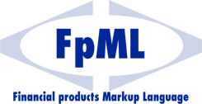

Messaging Structure
Technical Note – Version 1-0
9th April 2002

This version:
http://www.fpml.org/spec/tech-note-fpml-messaging-1-0-2002-04-09

Latest version:
http://www.fpml.org/spec/tech-note-fpml-messaging-1-0

Copyright © 1999 -2002. All rights reserved.

Financial Products Markup Language is subject to the FpML Public License.

A copy of this license is available at http://www.fpml.org/license/license.html .
Status of this Document:
This document is a technical note stating a possible approach to adding messaging to FpML. It represents the views across all currently active working groups. It is not an FpML recommendation.

Task Force Members:

- Steven Lord (UBS Warburg), chair, IRD Working Group
- Guy Gurden (SwapsWire), IRD Working Group
- Keri Jackson (independent), IRD Working Group
- Andrew Jacobs (IBM), Architecture Working Group
- Ned Micelli (Reuters), FX Working Group & Architecture Working Group
- Justin Oglethorpe (Citigroup) , FX Working Group
- Andrew Parry (Deutsche), EQD Working Group
- Rick Schumacher (Wall Street Systems) , FX Working Group
- Gavin Smith (RCP Consultants) , FX Working Group
- Bill Specht (Currenex) , FX Working Group
TABLE OF CONTENTS

1 Introduction 5
2 Summary Of findings 6
3 Workflow Model Sequence Diagrams 7
3.1 Price Request Sequence 7
3.2 Trade Request Sequence 7
3.3 Risk Management Sequence 8
4 Experimental DTDs 9
5 Other issues to be addressed 11
6 Other resources 12

Introduction
The FpML TaskForce, a working group with members from all other working groups, was formed in January 2002 to address and proposed recommendations on issues that cut across all working groups. This work was concluded in April 2002 and the recommendations incorporated into the FpML 3.0 Working Draft.

One of the items to address was the messaging structure required within FpML. The Taskforce made good progress in the time available but concluded that a separate Working Group would be required to continue the work. This technical note documents the work done on the messaging framework by the Taskforce and is intended to provide the starting point for the work of a future Messaging Working Group.

Summary Of findings
- The workflow model should ideally be documented in the form of UML sequence diagrams, with accompanying text. The Task Force felt that this was the best vehicle for analysing, agreeing and publicising the overall workflow structure. Detailed definition of the document schema would follow from the workflow model.
- The workflow model and the resultant schema structure should take into account the requirements of both business-to-business (B2B) and internal application-to-application (A2A) usage.
- The “trade” element that has survived into FpML 3.0 has always been unclear in meaning. It should be abandoned in favour of a message structure that supports capturing the details of the trade relevant to its state in the overall trade processing life cycle.
- FpML 3.0 will see the “party” element abstracted to the highest level from within “trade”. The Task Force’s initial analysis of message structure confirmed that this would be an improvement.
- The working assumption is that a generic workflow model that serves all the current asset classes (interest rate derivatives, equity derivatives and foreign exchange) can be devised, reflecting a high-level trade life cycle. It should be noted that the Task Force did not test this assumption systematically. To what extent commonality can be established at the next level down can only be determined by detailed analysis across all the asset classes. However, a few candidates for commonality have already been identified: instructions for settlement payments; and the timeout on a response to a quote request, for example.
- As well as covering the pre- and post-trade workflow, the model should address modification and cancellation events at each stage of the life cycle.
- Some form of message header will be required. This will pertain to the FpML document itself, and will be independent of any trade-specific header information.
- The three product working groups have not been consistent in their positioning of their product definitions within the workflow structure. The FX group, for example, has included optional payment instructions for the settlement of the trade. An agreed workflow model will provide a clearer framework. Some rework will be required to attach the FpML 3.0 product definitions to the appropriate workflow steps.

- The “portfolio” structure developed by the Task Force has been added to FpML 3.0 in the absence of any workflow structure in that version. The Task Force agreed that the message structure to be developed will ultimately improve the current proposal by identifying the workflow component(s) to which the “portfolio” concept is applicable.

Workflow Model Sequence Diagrams

The following three diagrams illustrate the exchanges involved in three standard workflow scenarios: requesting a price, making an order, and seeking a valuation of a position or portfolio.

Price Request Sequence
Figure 1: price request sequence diagram

Trade Request Sequence
Figure 2: trade request sequence diagram

Risk Management Sequence
Figure 3: risk management sequence diagram

Experimental DTDs
Based on the above model, the FpML dtd was reworked to include the workflow framework, as shown in figure 4 below.

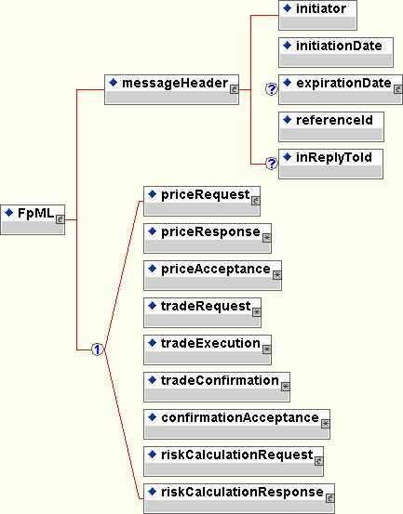

Figure 4: first-cut FpML dtd incorporating workflow

The Task Force took this one step further with an attempt to map the FX FpML 3.0 specification into this framework. Figure 5 below shows only the top level DTD extract resulting from this exercise.

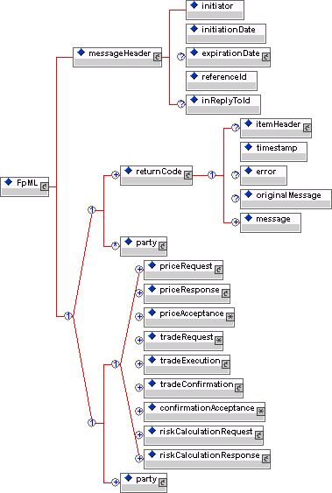

Figure 5: top level of FpML workflow dtd with FX incorporated at lower levels

While in broad terms this model was received favourably when discussed within the Task Force, it was recognised that the effort to re-engineer the FpML 3.0 Working Draft into this framework was significant and well beyond the scope of any of the current working groups.

Other issues to be addressed

- Should the workflow protocol include elements for exception handling (error codes, ability to return the original message as CDATA etc.)? Is this within the scope of FpML? Or of individual applications’ FpML wrappers or containers?

- Should one FpML instance document be limited to representing a workflow step for one single trade (e.g. a single price request)? Or should it be capable of representing many trades at the same workflow step (e.g. many price requests)?

- Does the term “affirmation” have a consistent meaning across all asset classes? The Task Force’s initial analysis indicates that it does not. Some take “affirmation” to mean the mutual agreement by the parties involved that they executed a trade, a process which precedes the formal confirmations process. Others (on the more operational side) take it to mean the confirmation of a confirmation, in a bilateral confirmations process. The Task Force’s first cut workflow model avoided the term for this reason, although it reappeared in the summary version presented to the Standards Committee.

- How does the FpML Messaging Structure work with other standards (eg SOAP)

Other resources
“FXML”: Citibank’s internal XML standard for FX products, originally based on FpML 1.0b. Available on the FpML FX Products Working Group’s e-groups site.

“TWIST”: the TWIST consortium’s FpML-based standard (www.twiststandards.org)

Global Straight Through Processing Association (www.gstpa.org/www.axion4.com)

