Trade Instructions Feed
Preliminary Draft Schema v 0.3
2005-01-28

Prepared by:

Brian Lynn
CTO, Global Electronic Markets LLC
brian.lynn@global-emarkets.com

for
Citco, Inc.

Trade Instructions Schema

TABLE OF CONTENTS
1. Introduction 4
2. Background 5
3. Architectural Approach 6
3.1. Overview 6
3.2. Key Features 6
4. Type Descriptions 7
4.1. Messaging 7
4.1.1. TradesCreated 7
4.1.2. TradesCorrected 7
4.1.3. TradesCancelled 8
4.2. Trade-Related Enhancements 8
4.2.1. TradeHeader 8
4.2.2. BlockTradeIdentifier 9
4.2.3. AllocationTradeIdentifier 9
4.2.4. PartyTradeInformation 9
4.3. Party-related Enhancements 10
4.3.1. Account 10
4.3.2. AccountId 10
4.3.3. Party 10
4.3.4. TradeSide 10
4.4. InstrumentTrade Product 11
4.4.1. InstrumentTrade 11
4.4.2. InstrumentDescription 12
4.4.3. InstrumentTradeQuantity 12
4.4.4. InstrumentTradePricing 13
4.4.5. InstrumentTradePrincipal 13
4.4.6. InstrumentTradeSettlement 14
4.4.7. InstrumentTradeFees(s) 14
4.4.8. InstrumentTradeCommission(s) 15
4.5. Repurchase Agreement Asset 15
4.6. Listed Option Asset 16
4.7. Simple Forward Asset 16
4.8. Utility Types 17
4.8.1. Net and Gross 17
5. Instrument Mapping 18
5.1. Product and Asset types 18
5.2. Instrument Id Schemes 20
6. Examples 21
7. Changes In This Version 22
7.1. Version 0.3 22
7.2. Version 0.2 22
8. Open Issues/Possible Future Work 23

Version History
Version | Date | Author | Status | Description
0.1 | 2005-01-19 | B. Lynn | Preliminary Draft | Initial draft, based on Citco input and FpML 4.2 account, party role, and allocation proposals.
0.2 | 2005-01-25 | B. Lynn | Preliminary Draft | Incorporates feedback from Citco and based on Citco sample trades - adjustments to trade identification, instrument trade quantity, principal, fees and commissions; plus change repo (back) to an underlying asset from a product.
0.3 | 2005-01-28 | B. Lynn | Draft | Incorporates more detail on mapping of various products to FpML, and some feedback from Citco, including removing the InsrumentTradeFunding element for now.

Introduction
This document describes the Trade Instructions draft schema for reporting block and allocation trades in a variety of listed and OTC asset classes.

This schema is based on
- the FpML 4.1 Trial Recommendation, dated December 2004,
- draft models for accounts, party roles, and allocations currently under discussion for FpML 4.2 in the FpML Messaging working group. (These types have been approved in principle, but some refinements may occur before FpML 4.2 is published).
- Citco requirements for data field values in a messaging feed.

This document is an initial draft, intended to be provided to stakeholders for feedback.

This document is divided into the following sections:
- Background
- Architectural Approach
- Description of types
  - Messaging types
  - Trades and extensions
  - Products
    - InstrumentTrade
    - RepurchaseAgreement
  - Utility Types
- Instrument mapping guidelines
- Examples
- Open Issues and Future Work

Provided with this document are:
- A schema directory including the TradeInstructions schema and the FpML schema it references.
- XML examples showing messages represented using the schema.
- A spreadsheet cross referencing the required Citco fields to the schema.

Background

Citco is seeking to develop a cross-asset class XML data feed for transmitting new, modified, and cancelled trades and trade allocations to prime brokers. It wishes to base this data feed on FpML to provide the broadest possible product coverage and widest use across the financial industry. Ultimately, Citco hopes that the data feed format can be used by a variety of service providers and market participants requiring this information.

The data feed needs to cover both OTC derivatives and listed instruments, so enhancements to FpML have been developed to allow listed instrument trades to be represented.

Architectural Approach

Overview
The Trade Instructions schema is based on the FpML 4.1 Trial Recommendation, issued Dec, 2004, and on enhancements proposed for FpML 4.2. It was developed based on the FpML Architecture 2.0 extension recommendations.

Key Features
Here is a summary of the key features of the Trade Instructions schema:
- Extensions to FpML are modeled in a separate XML namespace.
- The overall Trade Instructions feed is modeled as a series of individual messages to create, modify, and cancel trades. These messages are slightly enhanced versions of the FpML 4.1 “A2A” (application to application) messages, and are expected to be incorporated in some form into FpML 4.2.
- A number of approved FpML 4.2 enhancements have been represented in the Trade Instructions feed pending incorporation into FpML. These will be removed once they are in the FpML schema in a stable form.
- A new InstrumentTrade product has been defined, to represent trades of listed instruments. A number of additional related types have been defined to hold various aspects of the instrument trade.
- A new RepurchaseAgreement product has been defined to represent repo trades.

Type Descriptions

Messaging

Interactions are modeled using messages to do each of the following:
- Indicate that new trades have been created
- Indicate that trades have been corrected
- Indicate that trades have been cancelled.

In practice, it may be that a number of individual message documents would be grouped together into a single archive file for transmission to a recipient.

TradesCreated
This is used to indicate that a new block trade and/or the related allocation trades have been created. It contains:
- A normal FpML trade header
- Optional validation rules
- One or more trades
- One or more parties
- Zero or more tradeSides (these collect the parties performing different roles in a trade and are discussed further below).
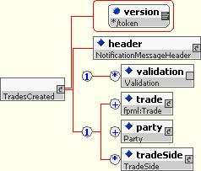

TradesCorrected
This is used to indicate a correction in previously sent trades. The first trade ID of each trade should be used as the identifier to determine which previous trades were changed. Other than the type, its content model is identical to the “TradesCreated” message.
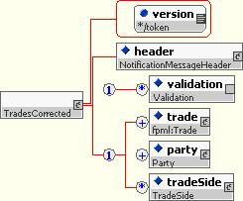

TradesCancelled
This is used to indicate that that previously sent trades were cancelled. Either the complete trades or just the trade identifiers cna be sent. In either case, the first trade ID per trade should be used to determine which previous trades were cancelled.

Its content model is similar to the “TradesCreated” message, except that either the complete trades or trade references (ie. trade identifiers only) can be supplied.
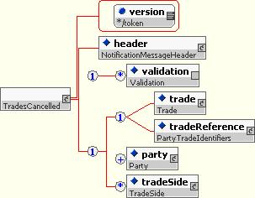

Trade-Related Enhancements
The FpML tradeHeader and partyTradeInformation have been slightly extended to allow extra information to be transmitted. The FpML partyTradeIdentifier has been extended to reflect the proposed FpML 4.2 enhancements for trade allocations.

TradeHeader
The standard FpML tradeHeader has been enhanced to include “entryDateTime”, to allow the date and time that the trade was originally entered to be recorded.

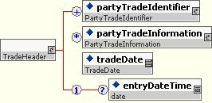

BlockTradeIdentifier
The blockTradeIdentifier is an extension of the FpML partyTradeIdentifier, used for denoting block trades. It comes from the FpML 4.2 proposal. The allocation trade ID elements allow a number of allocation trades to be linked to the block trade.
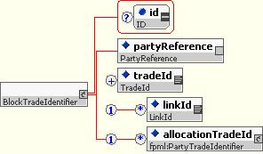

AllocationTradeIdentifier
The allocationTradeIdentifier is an extension of the FpML partyTradeIdentifier, used for denoting block trades. It comes from the FpML 4.2 proposal. The block trade ID element allows a block trade to be linked to the allocation trade.

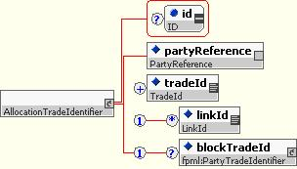

PartyTradeInformation
The FpML partyTradeInformation type has been extended to allow a traderName to be supplied as well as a trader ID. This might need a little more thought, as the trader name and ID wouldn’t be linked.

Party-related Enhancements
The Account and TradeSide definitions have been incorporated from FpML 4.2 proposals.

Account
The accountId and accountName identify the account. The accountAtParty reference indicates the party that manages the account, e.g. a prime broker or bank.
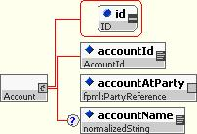

AccountId
The AccountId type contains a coding scheme attribute and a value for identifying accounts. It comes from the FpML 4.2 proposals
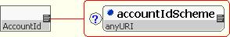

Party
The party has been extended to include 0 or more accounts. The accounts are those that are owned by the party, and may be located at a different party.
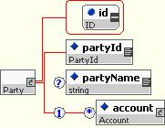

TradeSide
The TradeSide allows the precise roles of the different parties participating in a transaction to be specified. Each element is a reference to the party performing that role.

We have added the “clearingAccount” and “settlementAccount” references to this compared to the current FpML 4.2 proposal. These are currently under discussion in the FpML Messaging Working Group.
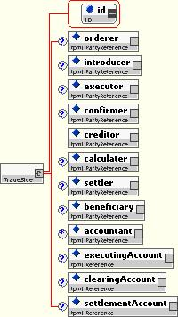

InstrumentTrade Product
This new product allows a trade of a predefined instrument, e.g. a listed instrument, to be represented.

InstrumentTrade
This is the overall product structure. It extends the FpML Product type, allowing it to be used in FpML Trades, and includes:
- TransactingPartyReference - a reference to the party or tradeSide (for more detail) that executed the transaction. We assume that the trade was anonymous as it was executed through an exchange/clearinghouse.
- A description of the instrument or a reference to a description contained in another trade (this avoids requiring that the instrument description information be repeated for each trade in a block trade).
- The quantity traded
- How it was priced
- The principal amount
- How it is to be settled
- Any fees or commissions owing.
- Any funding activity
Most of the above are contained within types that hold details of each of the above topics. See the following sections for more details.
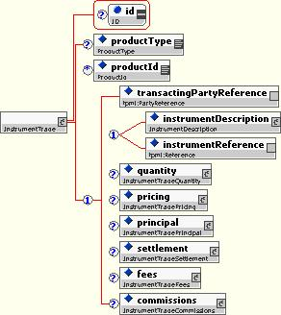

InstrumentDescription
This provides more details of the traded instrument:
- The instrument type allows a custom instrument type description to be supplied.
- The fpml:underlyingAsset allows specific details of the instrument to be supplied.
- The country allows the country of incorporation to be supplied.
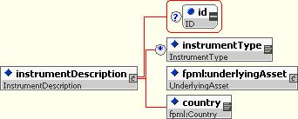

InstrumentTradeQuantity
This indicates the number of units of the instrument that were traded:
- Number - indicates how many were traded.
- Direction - indicates whether the asset was bought (sale or cover) or sold (sale or short sale).
- Position - indicates whether the transacting party is long (owns) or is short (borrows) the share.
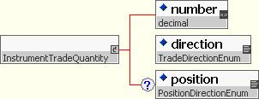

InstrumentTradePricing
This type provides information about the price paid for the instrument, in instrument or pricing currency.
- The price indicates the amount and currency per unit of the instrument. This is a “dirty” price, including accrued interest. It can gross and/or net price, and optionally a summary of fee and commission prices.
- The priceFactor indicates the unit size of the price, i.e. the factor by which the price needs to be multiplied when multiplied by the quantity of the instrument.
- The accruedInterestPrice indicates the price value per unit of any accrued interest.
- The principal element is a structure to indicate the value of the trade in instrument currency. (This element should perhaps be moved up to InstrumentTrade or into InstrumentTradeQuantity).

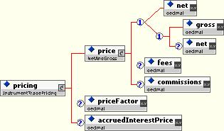

InstrumentTradePrincipal
This reports the principal value of the amount that was traded. It is typically reported in instrument currency.
- principalAmount - indicates the net and/or gross amount of the principal.
- capFactor indicates percentage of accreted principal since previous coupon payment that is owed to seller of bond.
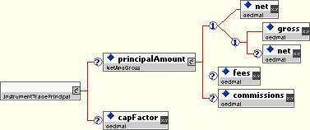

InstrumentTradeSettlement
This type reports how the trade is to be settled.
- Settlement currency indicates the currency in which the trade is settled.
- Settlement date indicate when the settlement occurs.
- Settlement amount indicates the net and/or gross value of the settlement, plus optionally a summary of the fees and commissions in settlement currency.
- Accrued interest indicates how much interest was accrued on the underlying instrument, if any.
- The fxRate indicates the FXConversion applied to convert between pricing and settlement currency.

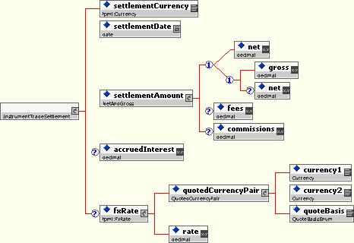

InstrumentTradeFees(s)
InstrumentTradeFees provides details on the fees owing on a transaction. It contains a collection of fee elements, each of type InstrumentTradeFee. Each instrument trade fee holds a specific fee type for the trade. This provides details on the calculation and destination of fees, in settlement currency. Its contents include:
- Type - the type of fee owing, e.g. SEC fee.
- Rate - (optional) the rate at which the fee is computed
- Value - the currency and amount of the fee
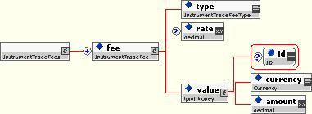

InstrumentTradeCommission(s)
InstrumentTradeCommissions provides details on the commissions owing on a transaction. It contains a collection of commission elements, each of type InstrumentTradeCommission. Each instrument trade commission holds a specific type of commission. It is base on the FpML 4.1 “Commission” structure, and adds an commission type and an optional receiverPartyReference, to indicate the party to which the commission is owed. The commission may be owed, for example, to a clearing broker or executing broker.

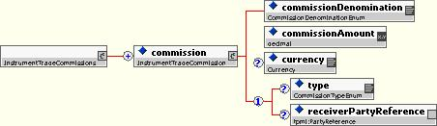

Repurchase Agreement Asset
The RepuchaseAgreement is a new FpML underlying asset providing a way of representing repo trades.

Its contents include, beyond those of the basic underlying asset:
- The type of repo agreement (open, term).
- The start and end dates of the repo period.
- The instrument that was repo’d.
- The quantity that was repo’d.
Open issues:
- Descriptions of options for “last repo”

Listed Option Asset
The ListedOption type (global element “option”) is a new underlying asset that represents simple options, typically those listed on an exchange. It adds to the standard FpML underlying asset these fields:

- The underlying asset - the asset that this option confers the right to buy or sell.
- The option type - whether the option allows the underlying asset to be bought (“call”) or sold (“put”).
- The expiration - the last day the option can be exercised.
- The strike - the price at which the option can be exercised.
- The settlement type - whether, when exercised, the option owner is given (or must deliver) the underlying asset (“physical” settlement), or the monetary value of the underlying asset less the strike (“cash” settlement).
- The exercise style - whether the option can be exercised only on the expiration date (“European”), or over a range of dates (“American”), or on specified dates (“Bermuda”).
- The multiplier - the number of units of the underlying asset per unit of the option.

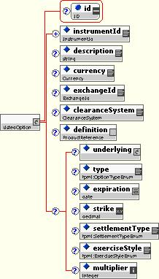

Simple Forward Asset
The SimpleForward type (global element “simpleForward”) is a new underlying asset that represents simple forwards. It does not provide a full product representation of the forwards, which are actually OTC products, but it does list key economic informaiotn. It adds to the standard FpML underlying asset these fields:

- The underlying asset - the asset that this forward contract will caused to be bought or sold
- The maturity - the day when the purchase or sale takes place.
- The forwardPrice - the price at which the sale will take place.
- The multiplier - the number of units of the underlying asset per unit of the forward.

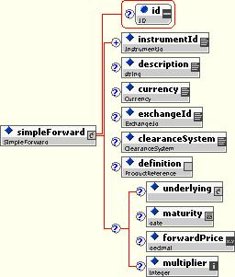

Utility Types

Net and Gross
This type allows a net amount, a gross amount, or both to be supplied, plus optionally a summary of fees and commissions.
- Gross amount indicates the amount of a trade before any fees or commissions.
- Net amount includes fees and commissions.
- Fees (optional) indicates the sum of all fees.
- Commissions (optional) indicates the sum of all commissions.
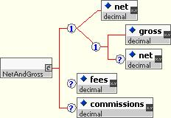

Instrument Mapping

The Trade Instructions feed needs to be able to accommodate a large number of specific instruments. This section describes how to map each type of instrument to the corresponding FpML/Trade Instructions type.

Product and Asset types
The following table describes how each type of product used by Citco is to be represented in FpML.

In the below, the first three columns represent Citco’s current instrument class and type codes and product name. These are provided as an example of a detailed product taxonomy based on actual business data. In future drafts of this specification, it is likely that these columns will be made more generic.

The “Product” column represents the FpML product to use. In most cases this will be a ti:instrumentTrade, i.e. a trade of an FpML underlying asset. The “Asset” colum lists the name of the FpML asset to use.

In the case of some OTC products, the preferred product to use is the corresponding detailed FpML product representation. However, if not much of the detailed representation is available, as an alternative in some cases there is a simplified “underlying asset” representation that may be used, as part of an instrumentTrade. If so, the asset to use is listed in the “Alternate Asset” column.

Citco Inst Class | Citco Inst Type | Citco Name | Product | Asset | Alternate Asset
1 | 1 | Equity | ti:instrumentTrade | equity
1 | 41 | Private Placement | ti:instrumentTrade | equity
1 | 62 | Warrant/Rights | ti:instrumentTrade | equity
1 | 63 | Internal Fund | ti:instrumentTrade | equity
1 | 64 | Deferred Fee | ti:instrumentTrade | equity
1 | 65 | External Investment | ti:instrumentTrade | equity
1 | 68 | Cash | ti:instrumentTrade | cash
2 | 6 | IR/Currency Swap | swap | - | simpleIrSwap
2 | 26 | Equity Swap | equitySwap | -
2 | 31 | Index Swap | n/a | n/a
2 | 32 | Commodity Swap | n/a | n/a
2 | 42 | FX Swap | fxSwap | -
2 | 51 | Metal Forward Swap | n/a | n/a
2 | 55 | Index Future Swap | n/a | n/a
2 | 60 | Fund Swap | n/a | n/a
2 | 69 | Commodity Forward | ti:instrumentTrade | ti:forward
2 | 70 | Implied Par Swap Rate | n/a | n/a
3 | 5 | Convertible Bond | ti:instrumentTrade | convertibleBond
3 | 21 | Government Bond | ti:instrumentTrade | bond
3 | 24 | Corporate Bond | ti:instrumentTrade | bond
3 | 73 | Credit Default Swap | creditDefaultSwap | - | simpleCreditDefaultSwap
3 | 74 | Bank Debt | ti:instrumentTrade | see deposit, termDeposit
3 | 75 | Credit Spread | n/a
4 | 15 | Swaption (Interest Rate) | swaption | - | ti:option
4 | 16 | OTC FX Option | fxAverageRateOption, fxBarrierOption, fxDigitalOption, fxSimpleOption, | - | ti:option
4 | 25 | Exotic Option | n/a |  | ti:option
4 | 35 | OTC Bond Option | n/a |  | ti:option
4 | 36 | Equity Option | equityOption | - | ti:option
4 | 37 | Commodity Future Option | ti:instrumentTrade | ti:option
4 | 40 | OTC Metal Option | n/a | n/a | ti:option
4 | 48 | IR Future Option | ti:instrumentTrade | ti:option
4 | 49 | Index Future Option | ti:instrumentTrade | ti:option
4 | 53 | Index Option | ti:instrumentTrade | ti:option
4 | 54 | Currency Future Option | ti:instrumentTrade | ti:option
4 | 58 | IR Future Option - Short Term | ti:instrumentTrade | ti:option
4 | 61 | Commodity Option (No Premium) | ti:instrumentTrade | ti:option
4 | 67 | Commodity Swaption | ti:instrumentTrade | n/a | ti:option
5 | 10 | Commodity Future | ti:instrumentTrade | future
5 | 11 | Commodity Spot | n/a
5 | 22 | Index Future | ti:instrumentTrade | future
5 | 23 | IR Future | ti:instrumentTrade | future
5 | 29 | Currency Future | ti:instrumentTrade | future
5 | 30 | Currency Proxy Future | ti:instrumentTrade | future
5 | 43 | IR Future Spot | ti:instrumentTrade | future
5 | 44 | Index Future Spot | ti:instrumentTrade | future
5 | 45 | Currency Future Spot | ti:instrumentTrade | future
5 | 47 | Index Proxy Future | ti:instrumentTrade | future
5 | 52 | Commodity Index Future | ti:instrumentTrade | future
5 | 56 | EFP | ti:instrumentTrade | future
5 | 57 | IR Future - Short Term | ti:instrumentTrade | future
5 | 66 | Single Stock Future | ti:instrumentTrade | future
5 | 72 | FRA Future | ti:instrumentTrade | future
7 | 19 | Forward Rate Agreement | fra |  | simpleFra
7 | 27 | Template FRA | n/a
8 | 4 | Currency | fxSingleLeg | -
8 | 12 | Currency Forward | fxSingleLeg | -
8 | 13 | Currency Deposit | termDeposit | - | deposit
8 | 34 | Metal Forward | ti:instrumentTrade | ti:forward
8 | 71 | Cross Rate | n/a
9 | 2 | Currency Option Volatility | n/a
9 | 3 | Benchmark Bond | n/a
9 | 7 | Index | ti:instrumentTrade | index
9 | 9 | Swaption Volatility | n/a
9 | 14 | Interbank Rate | ti:instrumentTrade | rateIndex
9 | 50 | Repo MTM | n/a
12 | 38 | Yield Curve Tenor | n/a
12 | 39 | Fund | ti:instrumentTrade | mutualFund, exchangeTradedFund
12 | 59 | Continous Cash Benchmarks | n/a

Instrument Id Schemes
This table identifies the instrument ID coding scheme URIs to be used for a variety of instrument IDs:

Type | Description | Coding Scheme URI
CUSIP |  | http://www.fpml.org/spec/2002/instrument-id-CUSIP-1-0
International CUSIP |  | TBD
GMI |  | TBD
ISIN |  | http://www.fpml.org/spec/2002/instrument-id-ISIN-1-0
OCS | Reuters external code | TBD
Old Tudor Code | Citco internal | http://www.citco.com/instrument-id-Tudor
Reuters RIC |  | http://www.fpml.org/spec/2003/instrument-id-Reuters-RIC-1-0
Rolfe & Nolan code |  | TBD
SEDOL | LSE daily official list | http://www.fpml.org/spec/2002/instrument-id-SEDOL-1-0
Ticker |  | TBD
TIC |  | TBD
TID | Citco internal | http://www.citco.com/instrument-id-TID
User1 | Citco internal | http://www.citco.com/instrument-id-User1
User2 | Citco internal | http://www.citco.com/instrument-id-User2
User3 | Citco internal | http://www.citco.com/instrument-id-User3
Valoren | Swiss instrument code | http://www.citco.com/instrument-id-Valoren

Examples
The following examples are provided:
- Citco_example.xml - an example of a TradesCreated message providing one block trade and two allocation trades for an equity.
The following examples may be provided in the future:
- TBD - an example of a TradesCorrected message
- TBD - an example of a TradesCancelled message
- TBD - an example of a repo
- Possibly other examples, e.g. other instruments, OTC products (IR swaps etc,).

Changes In This Version

Version 0.3
The following has changed since version 0.2:
- A new section, section 5, has been added to discuss mapping of instruments to FpML products and assets.
- Two new underlying assets have been added:
  - option - for simple options
  - forward - for simple forwards
- Some minor schema changes have been made:
  - The element InstrumentTrade/funding has been removed, and the corresponding type InstrumentTradeFunding. This held the repoStartDate.
  - The “executingAccount” in TradeSide has been renamed to “executionAccount”.
  - The type names for two enumerations, BuyOrSellEnum and LongOrShortEnum, have changed to TradeDirectionEnum and PositionDirectionEnun.
  - InstrumentTradeCommission/type was added, as was the corresponding CommisionTypeEnum, to indicate the type of commission more explicitly.
- The cross reference spreadsheet has been updated to reflect the latest version of the spec. Not all coding scheme URIs have been listed explicitly in XPath predicates. These will be updated in a future version.

Version 0.2
The following has changed since version 0.1:
- In PartyTradeInformation, traderName has been removed and portfolioName has been added
- InstrumentTradePrincipal has been moved out of InstrumentTradePricing and up to the InstrumentTrade root element.
- In pricing, principal, and settlement amounts, treatment of net and gross amounts (and values of fees and commissions) has been made consistent. This has resulted in changes to the NetAndGrossAmount type.
- Pricing currency is now assumed to be the same as instrument currency.
- RepurchaseAgreement has been changed to an Underlying Asset from a Product, to accommodate requirements in the sample data.
- In RepurchaseAgreement, DayCountFraction has been added.
- An optional funding element was added to InstrumentTrade to accommodate repo information, to accommodate information in the sample data.
- There have been a number of changes to the example to correspond to the above and to provide more accurate trade identification.

Open Issues/Possible Future Work
Following are some areas that might be addressed in future versions of the specification
- An example of a repo trade needs to be created. An example of a trade of an “option” asset should be created.
- The Equity Swap example in the Citco feed needs to be reviewed to determine how best to represent the information in the trade instructions feed (using the existing FpML EquitySwap structure, or based on the instrument trade structure). The InstrumentTrade structure appears to be closer to the data requirements of the trade instructions feed.
- We need to review the instrument to product and asset mappings and determine if any require adjustments.
- It would be useful to create examples of a variety of different products, both OTC and non-OTC.
- Possibly some usage rules or guidelines should be added

